**A**

**Project Report on**

HOTEL MANAGEMENT

**Submitted in partial fulfillment of the requirements for the award of the degree of**

Bachelor of Technology

**in**

Computer Science and Engineering

**by**

**Pratyush Singh**

**Roll no. : 2200970100124**

**Under the Supervision of**

**Mr. Rajwantbir Singh Kohli**



**Galgotias College of Engineering & Technology Greater Noida, Uttar Pradesh**

**India-201306 Affiliated to**



**Dr. A.P.J. Abdul Kalam Technical University Lucknow, Uttar Pradesh,**

**India-226031 November 2023**

|  |  |
| --- | --- |
| GEI logo | **GALGOTIAS COLLEGE OFENGINEERING & TECHNOLOGY**  **GREATER NOIDA, UTTAR PRADESH, INDIA- 201306 .** |

**CERTIFICATE**

This is to certify that the project report entitled Hotel Management System submitted by Mr. Pratyush Singh , 2200970100124 ,to the Galgotias College of Engineering & Technology, Greater Noida, Uttar Pradesh, affiliated to Dr. A.P.J. Abdul Kalam Technical University Lucknow, Uttar Pradesh inpartial fulfillment for the award of Degree of Bachelor of Technology in Computer science & Engineering is a bonafide record of the mini project work carried out by them under my supervision during the year 2023-24

**SIGNATURE SIGNATURE**

|  |  |
| --- | --- |
| **Mr. Rajwantbir Singh Kohli**  **Designatio**  **Dept.of CSE** | **Dr. Vishnu Sharma**  **Professor and head**  **Dept.of CSE& Allied Branches** |

**Abstract:**

* **Introduction:**

The Hotel Management System is a comprehensive software solution designed to streamline and optimize the operations of a hospitality establishment. It encompasses modules for reservation management, room allocation, billing, inventory control, and guest services. This system enhances efficiency by automating tasks such as check-ins, check-outs, and financial transactions. It also facilitates better customer service through a centralized database that stores guest preferences and history. With real-time reporting and analytics, hoteliers can make informed decisions to improve overall guest satisfaction and operational effectiveness. The Hotel Management System ultimately contributes to a seamless and organized hospitality experience.

* **Proposed Solution:**

The proposed Hotel Management System is a robust software solution aimed at revolutionizing the hospitality industry. It offers a user-friendly interface for efficient reservation management, room allocation, and check-in/check-out processes. The system integrates seamlessly with online booking platforms, ensuring real-time updates and reducing the risk of overbooking. Robust billing and invoicing modules streamline financial transactions, while inventory control features optimize resource utilization. The inclusion of a centralized guest database enhances personalized service delivery by storing preferences and history. The system also incorporates analytics tools for data-driven decision-making, contributing to improved operational efficiency and customer satisfaction. With this comprehensive solution, hotels can elevate their service standards and stay ahead in a competitive market.

* **Advantages:**

1. **Efficiency and Time Savings:** One of the primary advantages of a Hotel Management System is the automation of routine tasks such as reservation management, check-ins, and check-outs. This not only reduces the likelihood of errors but also significantly saves time for both hotel staff and guests.
2. **Accurate Financial Transactions:** The integrated billing and invoicing modules ensure precise and error-free financial transactions. This contributes to transparent accounting, minimizes discrepancies, and streamlines the overall financial management of the hotel.
3. **Enhanced Guest Experience:** A centralized guest database allows for the storage of guest preferences and history. This information enables personalized services, creating a more tailored and memorable experience for guests. This personalization contributes to increased customer satisfaction and loyalty.
4. **Effective Resource Management:** Hotel Management Systems include features for inventory control, optimizing the utilization of rooms, supplies, and services. This leads to efficient resource management, reducing waste and ensuring that the hotel operates at its best capacity.
5. **Streamlined Check-In/Check-Out:** The system facilitates a smooth check-in and check-out process, minimizing waiting times for guests and improving overall customer satisfaction.
6. **Real-time Room Allocation:** With real-time updates, the system ensures accurate and prompt room allocations, avoiding conflicts and enhancing the guest experience.
7. **Integrated Billing and Invoicing:** Hotel Management Systems streamline financial transactions, from billing to invoicing, reducing manual errors and improving the accuracy of financial records.
8. **Inventory Control:** The system helps in managing and optimizing inventory, ensuring that resources such as rooms, supplies, and services are utilized efficiently.
9. **Centralized Guest Database:** A centralized database stores guest preferences and history, enabling personalized services and creating a more memorable experience for guests.
10. **Online Booking Integration:** Integration with online booking platforms allows for seamless connectivity, making it easier for guests to make reservations and improving the hotel's online visibility.

**Table of contents:**

**List of tables:**

* **Customer:**

1. Reference no.
2. Name
3. Mother’s Name
4. Gender
5. Post Code
6. Mobile
7. E-mail
8. Nationality
9. Id Proof
10. Id no.
11. Address

* **Booking:**

1. Customer Phone no.
2. Check-in date
3. Check-out date
4. Room type
5. Available room
6. Meal
7. No. of days
8. Paid Tax
9. Actual total
10. Total cost
11. Bill

* **Details:**

1. Floor
2. Room no.
3. Room type

**List of figures:**

1. Use case diagram
2. Detailed user interface

* Home page
* Customer
* Booking
* Details
* Report

1. System Design

* High level architecture
* DFD
* Collaboration diagram

**List of abbreviations:**

1. HMS: Hotel Management System
2. GUI: Graphics User Interface
3. SQL: Structure Query Language
4. VS Code: Visual Studio Code

**List of nomenclature:**

* Guest Profile: Detailed information about guests including name, contact details, preferences, and history.
* Check-In/Check-Out: Processes related to guest arrivals and departures, including room assignments and invoicing.
* Financial Reports: Summaries of revenue, expenses, and financial performance.

**Chapters:**

# Introduction

1. **Problem Statement**

# Proposed Work

1. **Requirements**

Use Case Diagrams

# GUI Design

Detailed User Interface Design

# System Design

High-level architecture diagram

Data Flow Diagram (DFD)

# Testing

Test Cases & Result

# Conclusion, Limitations and Future Work

**Introduction**

*The project hotel management system is a web based application that allows the hotel manager to handle all hotel activities online. Interactive GUI and the ability to manage various hotel bookings and rooms make this system very flexible and convenient. The hotel manager is a very busy person and does not have the time to sit and manage the entire activities manually on paper. This application gives him the power and flexibility to manage the entire system from a single online system. Hotel management project provides room booking, staff management and other necessary hotel management features. The system allows the manager to post available rooms in the system. Customers can view and book room online. Admin has the power of either approving or disapproving the customer's booking request. Other hotel services can also be viewed by the customers and can book them too. The system is hence useful for both customers and managers to portably manage the hotel activities.*

**Problem Statement**

*In the dynamic and competitive hospitality industry, effective management of hotels is crucial for ensuring customer satisfaction, operational efficiency, and sustainable growth. However, many hotels still face significant challenges in their day-to-day operations, hindering their ability to provide seamless services and meet evolving customer expectations. The existing hotel management systems often lack integration, leading to inefficiencies and suboptimal performance.*

**Key Problems**

1. **Fragmented Systems:**

*Many hotels rely on disparate systems for reservations, check-ins, inventory management, billing, and other crucial functions. This fragmentation leads to data inconsistencies, delays, and increased chances of errors.*

1. **Limited Automation:**

*Manual processes for tasks such as check-ins, room assignments, and inventory updates are time-consuming and prone to errors. Limited automation hampers the ability to provide quick and efficient services to guests.*

1. **Poor Customer Experience:**

*Inconsistent and slow service delivery, caused by disconnected systems, negatively impacts the overall customer experience. Guests expect a seamless and personalized stay, and shortcomings in the current systems contribute to dissatisfaction.*

1. **Inefficient Inventory Management:**

*Many hotels struggle with inventory control, leading to overbookings, underutilization of resources, and difficulties in managing perishable goods. This inefficiency directly affects revenue and operational costs.*

1. **Data Security Concerns:**

*With the increasing reliance on digital systems, hotels face growing cybersecurity threats. Ensuring the security and confidentiality of guest information is paramount, and current systems may lack robust security features.*

1. **Lack of Real-time Insights:**

*Traditional hotel management systems often provide retrospective insights, making it challenging for management to make informed decisions in real-time. Timely data is crucial for adapting to market trends and optimizing operations.*

1. **Adaptability to Market Trends:**

*The hospitality industry is rapidly evolving, with new trends and technologies shaping guest expectations. Existing systems may struggle to adapt to these changes, limiting a hotel's ability to stay competitive.*

**Objective**

*The primary objective is to develop an Integrated Hotel Management System that addresses the aforementioned challenges by providing a unified platform for seamless operations. The system aims to enhance automation, improve customer experiences, ensure data security, optimize inventory management, and empower hotel management with real-time insights for informed decision-making.*

**Scope**

*The proposed system will encompass modules for reservations, check-ins, room assignments, billing, inventory management, reporting, and analytics. It will integrate these modules to eliminate data silos and enable a more holistic and efficient approach to hotel management. The system will prioritize user-friendly interfaces for both staff and guests while adhering to the highest standards of data security and privacy.*

**Significance**

*The successful implementation of an Integrated Hotel Management System will not only streamline operations but also contribute to increased customer satisfaction, revenue growth, and the overall competitiveness of the hotel in the dynamic hospitality landscape.*

**Use case diagram:**

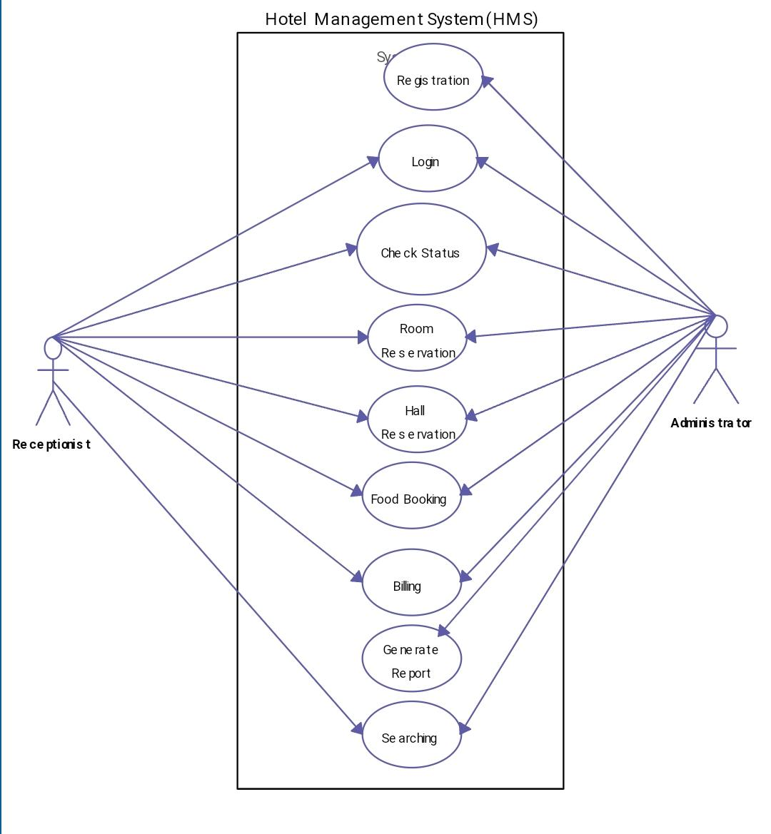

**GUI Diagram:**

1. **Registration or login page**

|  |
| --- |
| **Register here**  ***First Name***  ***Last Name***  ***Email id***  ***Contact number***  ***Select security answer***  ***Confirm Password***  ***Select security question***  ***Password***  ***License agreement: I agree to the terms and conditions*** |

1. **In case of login if user forgets password**

***Select security question***

***Select security answer***

***New password***

***RESET***

1. **Hotel management page(Adding customer details)**

HOTEL MANAGEMENT SYSTEM

***SHOWS ALL THE DETAILS OF THE CUSTOMER THAT BOOKS A ROOM AND ALL THE DATA THAT GETS SAVED IN THE DATABASE***

**RESET**

**DELETE**

**UPDATE**

**SAVE**

***SHOW ALL***

***SEARCH***

***SELECT OPTION***

***SEARCH BY***

**VIEW CUSTOMER DETAILS AND SEARCH**

***Address:***

***Id number:***

***Id proof type:***

***Nationality:***

***Email:***

***Mobile:***

***Postcode:***

***Gender:***

***Mother’s Name:***

***Customer name:***

**CUSTOMER DETAILS**

**MENU**

**CUSTOMER**

**BOOKING**

**DETAILS**

**REPORT**

**LOGOUT**

1. **Hotel management page(Booking details)**

HOTEL MANAGEMENT SYSTEM



**MENU**

**BOOKING DETAILS**

***SEARCH***

***SHOW ALL***

***SELECT OPTION***

***SEARCH BY***

***Check-in date:***

***Customer Phone no.:***

**CUSTOMER**

***SHOWS THE DETAILS IN RESPECT TO ROOMS ALLOTMENT AND BILL AND CHECK-IN AND CHECK-OUT DATE OF THE CUSTOMER***

***Check-out date:***

***Room type:***

***Available room:***

**BOOKING**

***Meal:***

***No. of days:***

***Paid tax:***

**DETAILS**

***Actual total:***

***Total cost:***

**BILL:**

**REPORT**

**SAVE**

1. **Hotel management page(Room additional details)**

**DELETE**

**UPDATE**

**CLEAR**

**ADD**

**ROOM TYPE**

**ROOM NO.**

**FLOOR**

HOTEL MANAGEMENT SYSTEM

**MENU**

**ROOM ADDING DEPARTMENT**

**CUSTOMER**

**SHOW ROOM DETAILS**

**Shows the details of all the rooms available or added recently . It also shows the type of the room eg : deluxe , luxury and also the accommodation eg: 2 seater or 3 seater etc.**

**NEW ROOMS ADD**

**BOOKING**

**DETAILS**

**REPORT**

**LOGOUT**

**System Design:**

* **High level architecture diagram:**

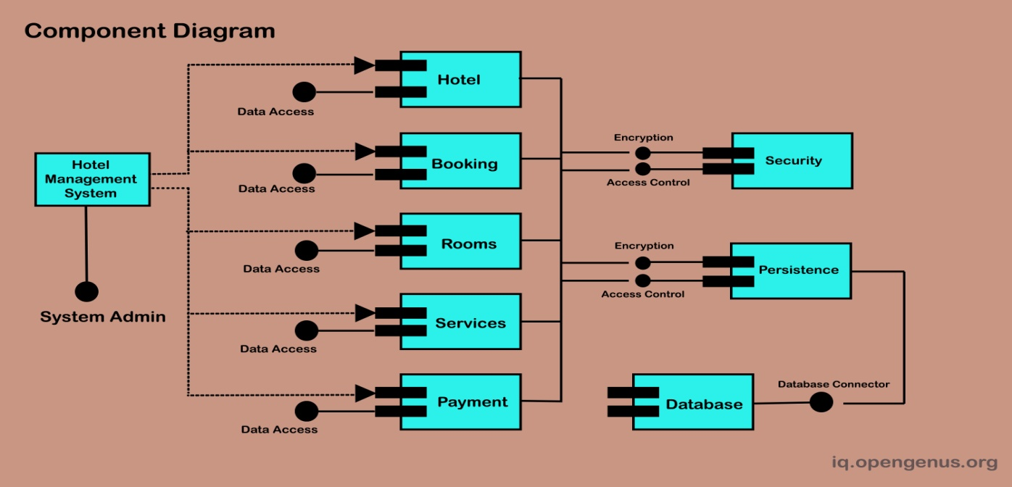

* **Data Flow Diagram:**

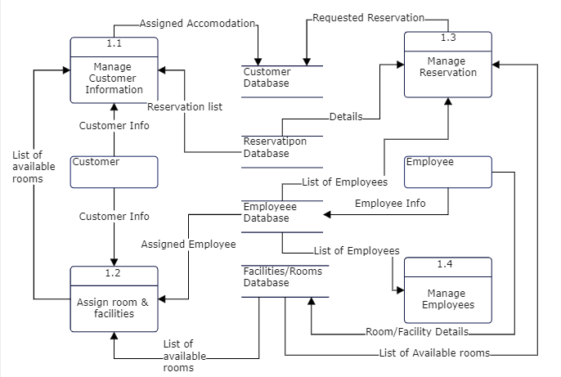

* **Collaboration diagram:**

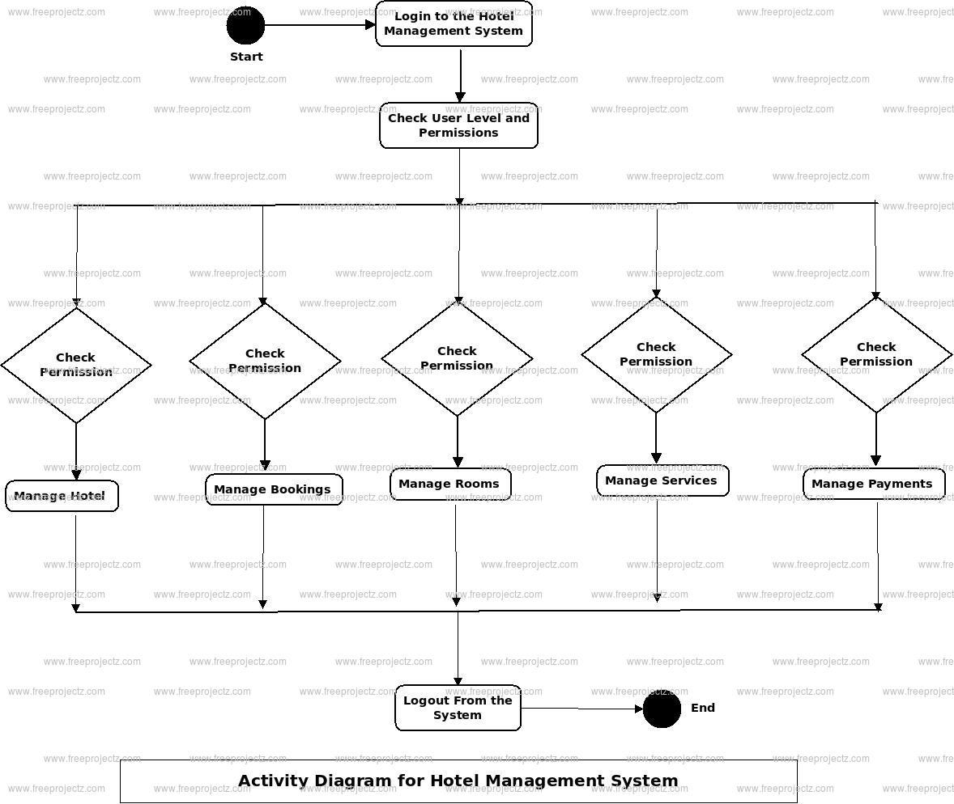

**Testing:**

|  |  |  |  |  |  |  |  |
| --- | --- | --- | --- | --- | --- | --- | --- |
| **Test Case No.** | **Step No.** | **Description** | **Input** | **Expected Result** | **Actual Result** | **Status (Passed/Failed)** | **Requirement No.** |
| 1 | 1 | … | …. | …. | …. | …. | …. |
|  | 2 | …. | …. | …. | …. | …. | …. |
| 2 | 1 | …. | …. | …. | …. | …. | …. |
|  |  |  |  |  |  |  |  |
|  |  |  |  |  |  |  |  |
|  |  |  |  |  |  |  |  |
|  |  |  |  |  |  |  |  |
|  |  |  |  |  |  |  |  |
|  |  |  |  |  |  |  |  |
|  |  |  |  |  |  |  |  |
|  |  |  |  |  |  |  |  |
|  |  |  |  |  |  |  |  |
|  |  |  |  |  |  |  |  |
|  |  |  |  |  |  |  |  |
|  |  |  |  |  |  |  |  |
|  |  |  |  |  |  |  |  |
|  |  |  |  |  |  |  |  |
|  |  |  |  |  |  |  |  |
|  |  |  |  |  |  |  |  |
|  |  |  |  |  |  |  |  |
|  |  |  |  |  |  |  |  |
|  |  |  |  |  |  |  |  |
|  |  |  |  |  |  |  |  |
|  |  |  |  |  |  |  |  |
|  |  |  |  |  |  |  |  |
|  |  |  |  |  |  |  |  |
|  |  |  |  |  |  |  |  |
|  |  |  |  |  |  |  |  |
|  |  |  |  |  |  |  |  |
|  |  |  |  |  |  |  |  |
|  |  |  |  |  |  |  |  |
|  |  |  |  |  |  |  |  |
|  |  |  |  |  |  |  |  |
|  |  |  |  |  |  |  |  |
|  |  |  |  |  |  |  |  |
|  |  |  |  |  |  |  |  |
|  |  |  |  |  |  |  |  |
|  |  |  |  |  |  |  |  |
|  |  |  |  |  |  |  |  |

**Limitations:**

*Hotel management systems are designed to streamline operations and enhance the overall efficiency of hotel businesses. However, like any software or system, they come with certain limitations. Here are some common limitations of hotel management systems:*

1. ***Initial Cost and Implementation:*** *The cost of acquiring and implementing a hotel management system can be significant. Small or budget-constrained hotels may find it challenging to invest in such systems.*
2. ***Training Requirements:*** *Staff members need to be trained to use the hotel management system effectively. Training can be time-consuming and may disrupt normal operations during the learning curve.*
3. ***Integration Issues:*** *Integration with existing systems and technologies can be complex. Compatibility issues may arise, especially when trying to integrate the hotel management system with other software or hardware solutions.*
4. ***Customization Challenges:*** *Some hotel management systems may lack flexibility in terms of customization to fit the specific needs of a hotel. This can be a limitation for hotels with unique or specific requirements.*
5. ***Dependency on Technology:*** *Hotel management systems heavily rely on technology. Any technical issues, such as server crashes, software bugs, or internet connectivity problems, can disrupt operations and affect guest satisfaction.*
6. ***Data Security Concerns:*** *As hotel management systems store sensitive guest information, data security is a significant concern. A breach of the system could lead to the compromise of personal information, potentially damaging the hotel's reputation.*
7. ***Scalability Issues:*** *Some hotel management systems may struggle to scale with the growth of a hotel business. This can be a limitation for hotels that plan to expand or increase their capacity in the future.*
8. ***User Interface Complexity:*** *Depending on the system, the user interface may be complex, especially for staff who are not tech-savvy. A complicated interface can lead to errors in bookings, check-ins, or other critical processes.*
9. ***Dependency on Internet Connection:*** *Many hotel management systems are cloud-based, requiring a stable internet connection. In areas with unreliable or slow internet, this dependency can pose challenges.*
10. ***Limited Support and Updates:*** *If the hotel management system provider does not offer regular updates or adequate customer support, hotels may face difficulties in resolving issues or adapting to new industry trends.*

**Future work:**

*The future of hotel management systems is likely to be shaped by advancements in technology and changing trends in the hospitality industry. Here are some potential areas of future work for hotel management systems:*

1. ***Artificial Intelligence (AI) Integration:***
   * *Incorporation of AI for personalized guest experiences, such as AI-driven chatbots for quick and efficient customer service.*
   * *Predictive analytics to forecast demand, optimize pricing strategies, and enhance resource allocation.*
2. ***IoT (Internet of Things) Integration:***
   * *Integration of IoT devices for smart room controls, energy management, and improved security.*
   * *RFID technology for keyless entry and tracking of guest movements within the hotel premises.*
3. ***Blockchain for Security:***
   * *Implementation of blockchain technology for enhanced security in handling guest data, ensuring transparency in transactions, and preventing fraud.*
4. ***Enhanced Mobility:***
   * *Mobile check-in and check-out options, as well as mobile room keys.*
   * *Integration with wearable devices for a seamless guest experience.*
5. ***Virtual and Augmented Reality:***
   * *Virtual tours of hotel facilities and rooms to help guests make informed booking decisions.*
   * *Augmented reality for on-site navigation and interactive guest experiences.*
6. ***Environmental Sustainability:***
   * *Integration of features to monitor and manage the hotel's environmental footprint.*
   * *Tools for energy and resource optimization to support sustainable practices.*
7. ***Advanced Analytics and Business Intelligence:***
   * *More sophisticated analytics tools for in-depth insights into guest behavior, preferences, and spending patterns.*
   * *Integration of business intelligence solutions for strategic decision-making.*
8. ***Voice-Activated Systems:***
   * *Implementation of voice-activated assistants in hotel rooms for hands-free control of room amenities and services.*
   * *Voice-activated concierge services for guest assistance.*
9. ***Enhanced Data Security and Compliance:***
   * *Continued focus on improving data security measures to address evolving cybersecurity threats.*
   * *Adherence to evolving data protection regulations and compliance standards.*
10. ***Cloud-Based Solutions:***
    * *Continued migration towards cloud-based hotel management systems for scalability, flexibility, and ease of updates.*
    * *Collaboration with other cloud-based services for seamless integration.*
11. ***Customer Relationship Management (CRM) Enhancement:***
    * *Integration of advanced CRM tools to personalize guest interactions and loyalty programs.*
    * *Utilization of data analytics to anticipate guest needs and enhance the overall guest journey.*
12. ***Global Distribution System (GDS) Integration:***
    * *Improved connectivity with GDS platforms to expand the hotel's reach and increase visibility.*
    * *Integration with emerging online travel agencies and platforms.*

**Conclusion:**

*In conclusion, a hotel management system is a valuable tool for streamlining operations, improving efficiency, and enhancing the overall guest experience in the hospitality industry. However, like any technology, it comes with its set of limitations and challenges. The decision to implement a hotel management system should be carefully considered, taking into account the specific needs and constraints of the hotel.*

*The benefits of a hotel management system include automation of routine tasks, centralized data management, improved accuracy in bookings and billing, and enhanced communication among staff members. This, in turn, contributes to better customer service and overall operational efficiency.*

*On the flip side, challenges such as the initial cost of implementation, staff training requirements, integration issues, and concerns about data security must be acknowledged. The system's scalability, user interface complexity, dependency on technology, and reliance on internet connectivity are additional factors that hotels need to carefully evaluate.*

*Despite these limitations, many hotels find that the advantages of implementing a well-suited hotel management system far outweigh the drawbacks. It's crucial for hoteliers to conduct thorough research, choose a system that aligns with their unique requirements, and ensure ongoing support and updates from the system provider. By doing so, hotels can leverage technology to stay competitive, provide exceptional guest experiences, and efficiently manage their operations in the dynamic and evolving hospitality industry.*